Module 7: Aurora Assignment
Problem Statement:
You work for XYZ Corporation. Their application requires a SQL service that can
store data which can be retrieved if required. Implement a suitable RDS engine
for the same.
While migrating, you are asked to perform the following
tasks:
1. Create an AuroraDB Engine based RDS Database.
2. Create 2 Read Replicas in different availability zones for better
infrastructure availability.

Task 1:
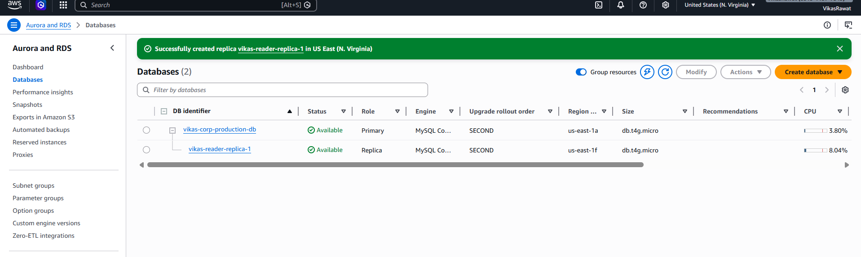
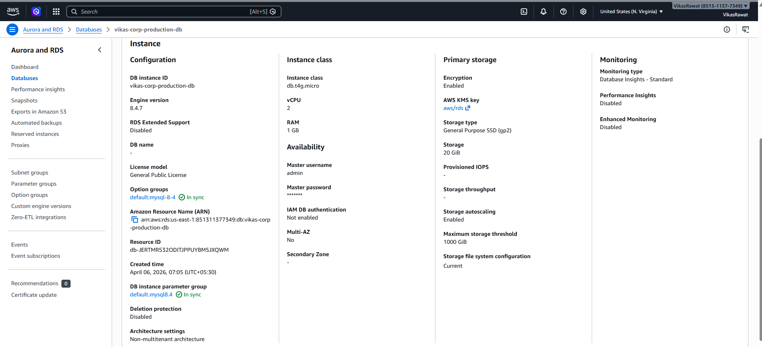

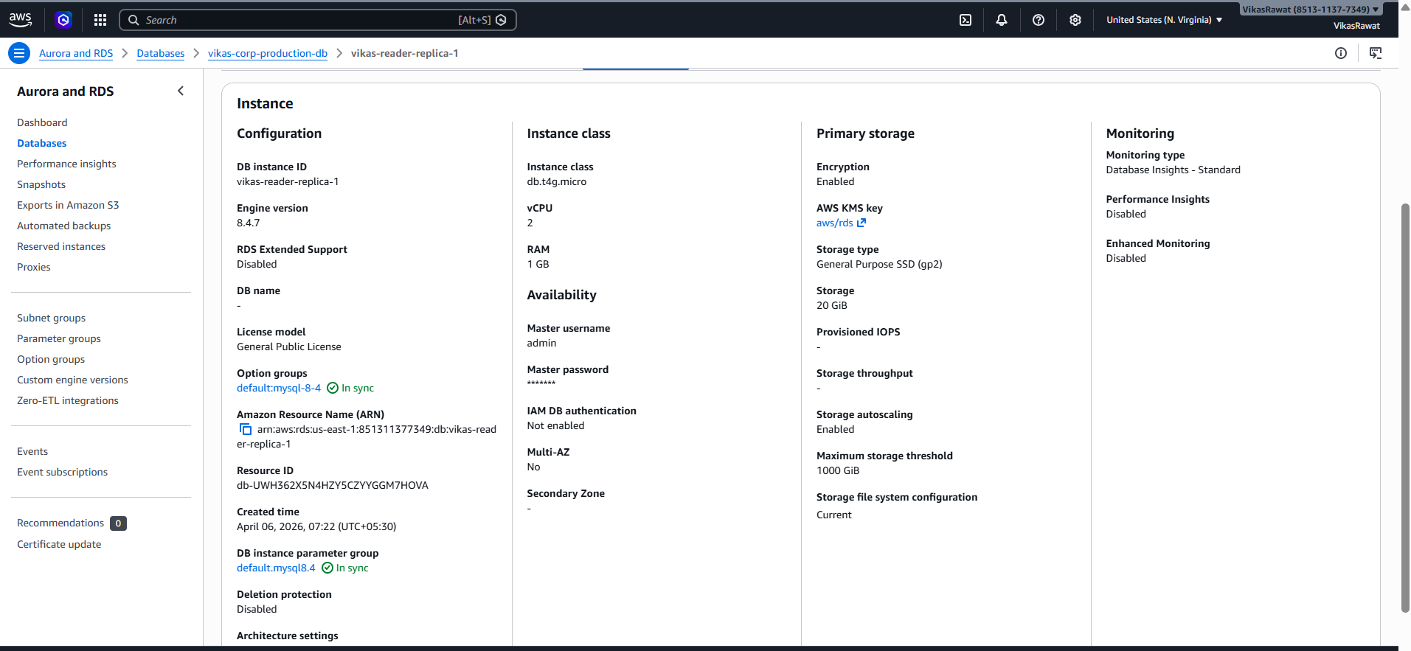

Not able to create more replica due to limit of free account.

